**Changes in bootnet version 1.3**

**Handling of Missing Data**

**Previous default behavior**

Several of the most commonly used default estimators in bootnet (e.g., *EBICglasso*, *ggmModSelect*, and *pcor*) rely on a correlation matrix as input, which is computed in the *estimateNetwork* function. When data are missing, such an input correlation matrix can not be computed directly. The default behavior was to then instead compute correlations *pairwise*. While this works (as it leads to a network without errors), pairwise estimation does come with a complication: the network estimation routines also require a *sample size* (e.g., for the BIC computation). This was controlled with the *sampleSize* argument, which had only two options: *maximum* (the old default), which simply set the sample size to all rows in the data, and *minimum*, which set the sample size to the number of rows that had no missing data at all. To understand why these are both problematic, consider the following dataset:

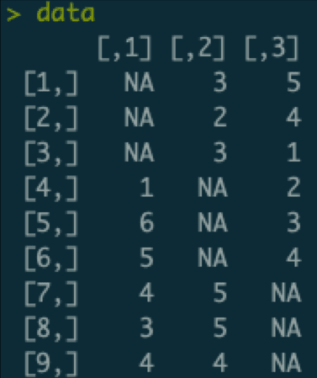

An example dataset with missing data.

In this dataset, there are three variables (columns), nine cases (rows). Some of the data are missing: only six observations are available per variable and only two observations are available per case. We can use pairwise estimation to compute the input correlation matrix:

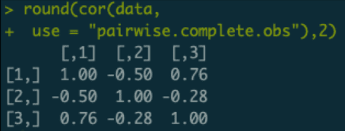

Pairwise estimated correlation matrix.

Of note, each element in this correlation matrix is only based on **three** observations. For example, the correlation between variables two and three is only based on the data of the first three cases who do not have missing values on either variable 1 or 2. If we now set the sample size to the maximum (the old default), we would subsequently estimate a network thinking we have nine observations. This would be problematic, as we would severely overestimate how confident we are about these correlations, and subsequently may include false edges in our network. If we would use the minimum sample size, we are left with a sample size of zero, which would underestimate our confidence (plus likely lead to some errors).

**New default behavior**

In the new version of bootnet, three more options are added: *pairwise_average* (the new default), *pairwise_minimum*, and *pairwise_maximum*. These set the sample size to the average, minimum, or maximum sample size used for each individual correlation. In this case, all three options would set the sample size to three, which is a much better description of the data.

Of note, technically using a pairwise correlation matrix as input to a likelihood based method (e.g., *EBICglasso*, *ggmModSelect*, and *pcor*) is not correct. This is because the likelihood function of the multivariate Gaussian only becomes a function of the summary statistics (means, variances and covariances) when no data is missing. All these methods compute the likelihood based on the input summary statistics, and hence even though performance is ok using a pairwise correlation matrix does not return the correct likelihood. A more technically sound method of dealing with missings is to compute the likelihood per case or per block of observed data with the same missingness pattern. One such a method is full information maximum likelihood (FIML) estimation. For confirmatory fit, FIML is recommended over pairwise estimation of the input correlations. For exploratory search, the algorithms in *bootnet* tend to perform a bit better at lower sample sizes than the algorithms included in *psychonetrics*, but FIML will start outperforming at larger sample sizes.

**Other changes in bootnet 1.3**

Beyond the sample size change, there are a few additional changes in the new version of *bootnet*:

* Several estimators now support the argument *corMethod = “spearman”*, which will make it much easier to use Spearman correlations instead of polychoric correlations as input to some of the estimators. A future version of bootnet may make this default behavior.
* Ever since the release of the first paper on *bootnet*, the intended method of specifying a custom estimator function was by supplying a custom function to the *fun* argument. Before this, I had another more complicated method implemented, using arguments such as *graphFun*, and *estFun*. These were not really used and are now no longer supported.
* The help file of *estimateNetwork* also lists the functions used as default function for the *fun* argument. For example, *default = “EBICglasso”* sets the function *bootnet_EBICglasso* to the *fun* argument, allowing you to use any argument from *bootnet_EBICglasso* in *estimateNetwork*. These default functions themselves, however, are not intended to be used manually (as is explained in the help file). Because many people do use these manually, the new version of bootnet will simply return an error if such a function (e.g., *bootnet_EBICglasso*) is used directly. This can be overwritten with *unlock = TRUE*, though that is not recommended.

**The *ggmModSelect* Algorithm**

While not really a change in bootnet, I recently made a figure explaining the increasingly commonly used *ggmModSelect* algorithm in qgraph and bootnet:

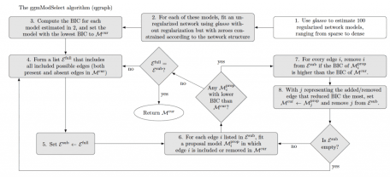

Outline of the *ggmModSelect* algorithm.

**Changes in psychonetrics version 0.5**

Some of these changes also include changes in the earlier released version 0.4. Note that this blog post describes version 0.5.1, which is currently submitted to CRAN but may not yet be updated.

**New *modelsearch* algorithm**

Inspired by the *ggmModSelect* algorithm explained above, the new version of *psychonetrics* now contains a variant of this algorithm that makes use of significance levels and modification indices. This algorithm is implemented in the *modelsearch* function in *psychonetrics*, and works as follows:

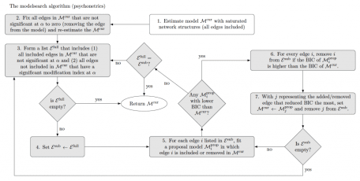

The *modelsearch* algorithm currently included in *psychonetrics*.

The algorithm is explained in more detailed and evaluated in simulation studies on latent network modeling with time-series and panel data. Generally it performs well in retrieving the network structure, being more sensitive than other algorithms in *psychonetrics* while retaining high specificity. Of note, however, is that just like the *ggmModSelect* algorithm the algorithm relies on many model evaluations and can be very slow with larger network models (e.g., more than 20 nodes). While the model is faster than *ggmModSelect* in theory (less model evaluations needed), it is currently slower in practice due to *psychonetrics* being slower than *glasso* in fitting given network structures.

**Code example of the modelsearch algorithm**

An example of the algorithm is below:

# Load libraries:

library("bootnet")

library("psychonetrics")

library("qgraph")

library("dplyr")

# Random seed:

set.seed(1)

# Construct a network

truenet <- genGGM(12)

# Generate data:

data <- ggmGenerator()(500, truenet)

# ggm model:

mod <- ggm(data)

# Estimate model:

mod <- mod %>% prune %>% modelsearch

# Obtain network:

estnet <- getmatrix(mod, "omega")

# Plot results:

layout(t(1:2))

qgraph(truenet, title = "True network", theme = "colorblind")

qgraph(estnet, title = "Estimated network", theme = "colorblind")

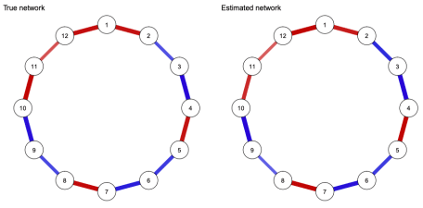

Example of the *modelsearch* algorithm.

**Maximum Likelihood Covariances as Input**

All models in *psychonetrics* can be estimated using a variance-covariance matrix as input. Previously, a confusing aspect of *psychonetrics* was that it expected a *maximum likelihood* (ML) estimate of the variance-covariance matrix (denominator *n*), while the default R function *cov* returns an unbiased (UB) estimate of the variance-covariance matrix (denominator *n-1*).

Three changes in *psychonetrics* now simplify this behavior. First, the *covML* function can be used to obtain a ML variance-covariance matrix, and the functions *covUBtoML* and *covMLtoUB* can be used to transform between ML and UB estimates. Second, all models now contain the argument *covtype*, which can be specified to determine which type of input covariances were used (if *covtype = “UB”* the input variance-covariance matrix will be transformed). This allows you to use the UB estimates from the base R *cov* function in the input as well. Finally, if *covtype* is not specified *psychonetrics* will make an educated guess by seeing if UB or ML estimates are more likely to result from integer valued input data (as many psychological datasets are encoded using only integers).

For example, we can replicate the above analysis exactly using the input means and covariances:

# means:

means <- colMeans(data)

# UB covs:

covmat <- cov(data)

# ggm model:

mod2 <- ggm(means = means, covs = covmat,

covtype = "UB", nobs = 500)

# Estimate model:

mod2 <- mod2 %>% prune %>% modelsearch

# Show these are equal:

compare(rawdata = mod, summary = mod2)

# Gives identical fit

**Correlations as input**

Already included in version 0.4, *psychonetrics* now supports having a correlation matrix as input. Typically, correlation matrices are treated as variance-covariance matrices in network estimation (e.g., this is what *EBICglasso* and *ggmModSelect* do), which leads to minimal problems but is technically not correct. The reason this is not correct is that the *variances* are also estimated, while these are already known to be exactly 1 in correlations. Hence, not taking precautions when using correlations as input to an estimator that expects a variance-covariance matrix can lead to some biases, such as incorrect standard errors. The *varcov* family of *psychonetrics* now supports using a correlation matrix as input through the argument *corinput = TRUE*, in which case the variances are not estimated but determined from the network structure. Future updates will also bring this argument to other model families. In the example above, the following code can be used to obtain the same network structure:

# Correlation estimate

cormat <- cor(data)

# ggm model:

mod3 <- ggm(

covs = cormat,

corinput = TRUE,

covtype = "ML", # <- not needed in 0.5.1

nobs = 500)

Note that in this model, only network parameters are estimated and no means or scaling parameters are included (*meanstructure = FALSE*):

> mod3 %>% parameters

Parameters for group fullsample

- omega (symmetric)

var1 op var2 est se p row col par

V2 -- V1 -0.35 0.032 < 0.0001 2 1 1

V12 -- V1 -0.39 0.032 < 0.0001 12 1 2

V3 -- V2 0.32 0.033 < 0.0001 3 2 3

V4 -- V3 0.38 0.031 < 0.0001 4 3 4

V5 -- V4 -0.38 0.031 < 0.0001 5 4 5

V6 -- V5 0.29 0.033 < 0.0001 6 5 6

V7 -- V6 0.36 0.032 < 0.0001 7 6 7

V8 -- V7 -0.38 0.032 < 0.0001 8 7 8

V9 -- V8 0.24 0.034 < 0.0001 9 8 9

V10 -- V9 0.38 0.033 < 0.0001 10 9 10

V11 -- V10 -0.32 0.034 < 0.0001 11 10 11

V12 -- V11 -0.25 0.035 < 0.0001 12 11 12

**WLS estimation of ordered data**

Many datasets used for network estimation contain ordered categorical data (e.g., 4 point liker scale data), for which no good methods currently exist. A common way of handling this type of data, is to use polychoric correlations rather than Pearson correlations, as is typical in structural equation modeling (SEM) literature. While polychoric correlations are much better at estimating the correlation between two ordered categorical variables, using them as input in likelihood based network estimation routines (e.g,. *EBICglasso* and *ggmModSelect*) does pose several problems. This is a problem because the likelihood based method assumes the input correlations are Pearson correlations, which are much more stable, and hence using polychoric correlations can overestimate the confidence in correlations, compounding in overconfidence in the network structure. In fact, using polychoric correlations as input to a likelihood based method is technically wrong as the likelihood derived using polycoric correlations is not equal to the true likelihood of the data, much like the case with pairwise estimates above.

Because of this reason, it is typical for SEM analyses to not use maximum likelihood estimation but rather weighted least squares (WLS) estimation when analyzing ordered categorical data using polychoric correlations. I have now implemented WLS estimation for GGM models in *psychonetrics*, and hope to extend this to all other model families soon. WLS estimation more appropriately adjusts standard errors to account for instability in the polychoric correlations, and therefore leads to more conservative estimators. Another benefit of WLS estimation is that it can naturally handle missing data through pairwise estimation (standard errors are automatically properly adjusted). The downside, however, is that WLS estimation seems to be *very* conservative and requires much larger datasets (e.g., thousands of cases) to reliably estimate network structures (especially when these are dense).

To use WLS estimation of ordered categorical data in *psychonetrics*, simply use *ordered = TRUE* and *missing = “pairwise”* in the *varcov* model family:

# Generate data:

data <- ggmGenerator(ordinal = TRUE, nLevels = 3)(500, truenet)

# ggm model:

mod4 <- ggm(data, ordered = TRUE, missing = "pairwise")

**The Ising Model**

This year marks the 100th year since the [Ising model](https://en.wikipedia.org/wiki/Ising_model) was originally invented by Wilhelm Lenz, and what better way to celebrate this occasion by implementing the Ising model in *psychonetrics*? In version 0.5 the Ising distribution is now included as first distribution besides the Gaussian distribution. The function *Ising* can be used to specify the Ising model, the first model that uses this distribution (and which is simply identical to the distribution). Future versions of *psychonetrics* will likely see other models using this distribution

**Important aspects of the Ising model implementation**

Some important things to note are:

* Currently only maximum likelihood is supported, which requires the computation of the expensive *partition function*. To this end, the Ising model is currently only practically useable up to 20 nodes or so.
* Just like Gaussian models, the model is actually fitted to the pairwise summary statistics (means and sums of squares). This means that all fit measures are also comparing the fitted Ising model to a ‘saturated’ Ising model in which all edges are present, similar to how GGMs and SEM models are fitted. This marks a departure from how such a model would be evaluated in typical loglinear modeling settings. A future version of *psychonetrics* will also include these fit indices.

**Ising model estimation example**

The following code gives an example of Ising estimation:

# Load libraries:

library("psychonetrics")

library("qgraph")

library("dplyr")

library("IsingSampler")

library("igraph")

# Random seed:

set.seed(1)

# Construct a network

truenet <- 0.25 * as.matrix(get.adjacency(watts.strogatz.game(1,12,1,0)))

# Generate data:

data <- IsingSampler(1000, truenet, rep(0, 12), responses = c(-1, 1))

# Ising model:

mod5 <- Ising(data)

# Estimate model:

mod5 <- mod5 %>% prune %>% modelsearch

# Obtain network:

estnet <- getmatrix(mod5, "omega")

# Plot results:

layout(t(1:2))

qgraph(truenet, title = "True network", theme = "colorblind")

qgraph(estnet, title = "Estimated network", theme = "colorblind")

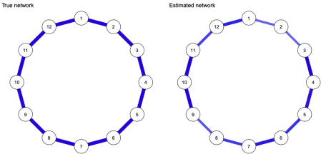

Estimated Ising model.

**Fitting an Ising model to summary statistics**

A benefit of the Ising model implementation in *psychonetrics* is that the model can be fitted to summary statistics (means and covariances), as long as these are derived from dichotomous data. For example, the following code uses the means, and variance-covariance matrix as input (note, this gives a bug in 0.5.0, but is fixed in 0.5.1):

# Means:

means <- colMeans(data)

# Covariances:

covmat <- cov(data)

# Ising model:

mod6 <- Ising(means=means, covs=covmat, responses = c(-1,1), nobs = 1000)

# Estimate model:

mod6 <- mod6 %>% prune %>% modelsearch

# Compare models:

compare(

rawdata = mod5,

summarystatistics = mod6

)

# These models are identical!

**Multi-group models and temperature estimation**

Like the Gaussian models, the Ising model implementation in *psychonetrics* allows for multgroup models. The beta parameter is very important in theoretical work however.

Using a multigroup analysis, the beta parameter becomes identified in each group beyond the first after placing equality constrains on the network and/or threshold parameters (much like variances of latent variables becoming identified in a multigroup SEM). To exemplify this functionality, and as a surprise for Jonas Dalege’s PhD defense, I gathered data online and among friends and colleagues of Jonas Dalege on ten dichotomous (yes/no) attitude items. This data is included in *psychonetrics* as the dataset *Jonas*. Code to reproduce the analysis are in the help file of the *Ising* function, as well as below:

library("psychonetrics")

library("dplyr")

# Load dataset:

data("Jonas")

# Variables to use:

vars <- names(Jonas)[1:10]

# Arranged groups to put unfamiliar group first (beta constrained to 1):

Jonas <- Jonas[order(Jonas$group),]

# Form saturated model:

model1 <- Ising(Jonas, vars = vars, groups = "group")

# Run model:

model1 <- model1 %>% runmodel

# Prune-stepup to find a sparse model:

model1b <- model1 %>% prune(alpha = 0.05) %>% stepup(alpha = 0.05)

# Equal networks:

model2 <- model1 %>% groupequal("omega") %>% runmodel

# Prune-stepup to find a sparse model:

model2b <- model2 %>% prune(alpha = 0.05) %>% stepup(mi = "mi_equal", alpha = 0.05)

# Equal thresholds:

model3 <- model2 %>% groupequal("tau") %>% runmodel

# Prune-stepup to find a sparse model:

model3b <- model3 %>% prune(alpha = 0.05) %>% stepup(mi = "mi_equal", alpha = 0.05)

# Equal beta:

model4 <- model3 %>% groupequal("beta") %>% runmodel

# Prune-stepup to find a sparse model:

model4b <- model4 %>% prune(alpha = 0.05) %>% stepup(mi = "mi_equal", alpha = 0.05)

# Compare all models:

compare(

`1. all parameters free (dense)` = model1,

`2. all parameters free (sparse)` = model1b,

`3. equal networks (dense)` = model2,

`4. equal networks (sparse)` = model2b,

`5. equal networks and thresholds (dense)` = model3,

`6. equal networks and thresholds (sparse)` = model3b,

`7. all parameters equal (dense)` = model4,

`8. all parameters equal (sparse)` = model4b

) %>% arrange(BIC) %>% select(model, DF, BIC)

In line with the predictions, a sparse network with equal network and threshold parameters but different beta parameters fits best (according to BIC). Further in line with the prediction, the group familiar with Jonas featured a lower temperature (higher beta parameter):

# Extract beta:

beta <- unlist(getmatrix(model3b, "beta"))

# Standard errors::

SEs <- model3b@parameters$se[model3b@parameters$matrix == "beta"]

# Make a data frame:

df <- data.frame(

temperature = 1/beta,

group = names(beta),

lower = 1 / (beta-qnorm(0.975) * SEs),

upper = 1 / (beta+qnorm(0.975) * SEs),

stringsAsFactors = FALSE

)

# Some extra values:

df$fixed <- [is.na](http://is.na)(df$lower)

df$group <- factor(df$group, levels = c("Doesn't know Jonas", "Knows Jonas"))

# Create the plot:

library("ggplot2")

g <- ggplot(df,aes(x=as.numeric(group), y = temperature, ymin = lower, ymax = upper)) +

geom_line() +

geom_errorbar(width = 0.05) +

geom_point(cex = 5, colour = "black") +

geom_point(aes(colour = fixed), cex = 4) + theme_bw() +

xlab("") + ylab(expression(paste("Temperature (",1/beta,")"))) +

scale_x_continuous(breaks = 1:2, labels = levels(df$group), expand = c(0.1,0.1)) +

scale_y_continuous(expand = c(0,.1), limits = c(0,1)) +

theme( panel.grid.major.x = element_blank(),panel.grid.minor.x = element_blank())+

ggtitle(expression(paste("Model 6: 2 groups; ",bold(Omega)," sparse & equal; ",bold(tau)," equal; ",beta," free"))) +

scale_colour_manual(values = c("black","white")) +

theme(legend.position = "none")

# Plot:

print(g)

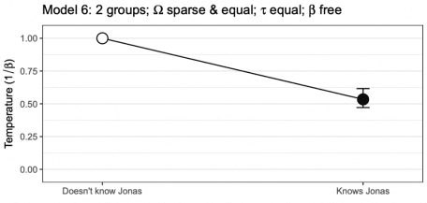

Finally, the estimated network structure can also be retrieved:

# Make labels:

labels <- c("good scientist",

"wears beautiful\njeans",

"cares about\npeople like you",

"solve economics",

"hardworking",

"honest",

"in touch with\nordinary people",

"knowledgeable",

"can't make up\nhis mind",

"gets things done")

# Extract network structure and thresholds:

network <- getmatrix(model3b, "omega")[[1]]

thresholds <- getmatrix(model3b, "tau")[[1]]

# Scale thresholds for colors:

scaledthresh <- as.vector(thresholds / (2*max(abs(thresholds))))

# Make colors:

cols <- ifelse(scaledthresh < 0, "red", "darkblue")

cols[scaledthresh>0] <- qgraph:::Fade(cols[scaledthresh>0],alpha = scaledthresh[scaledthresh>0], "white")

cols[scaledthresh<0] <- qgraph:::Fade(cols[scaledthresh<0],alpha = abs(scaledthresh)[scaledthresh<0], "white")

# Plot network and save to file:

qgraph(network, layout = "spring", labels = labels,

shape = "rectangle", vsize = 15, vsize2 = 8,

theme = "colorblind", color = cols,

cut = 0.5, filetype = "png", filename = "Jonas",

repulsion = 0.9)

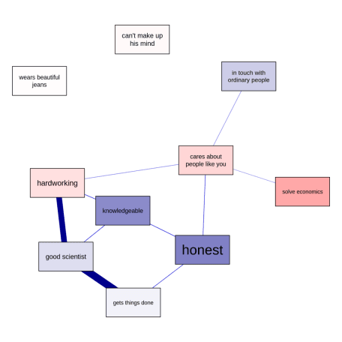

Estimated multigroup Ising network structure.

Of note, however, this analysis is very preliminary, and we are still working out the best way in which such multigroup Ising model analyses could be performed. If you have any thoughts for improvement, please let me know!